**Tutorial - Adding a Column to a Board**

(Info)This tutorial only applies if you are *not* using [Simplified Workflow](https://confluence.atlassian.com/agile/jira-agile-user-s-guide/configuring-a-board/configuring-columns/using-jira-agile-simplified-workflow). If you are using [Simplified Workflow](https://confluence.atlassian.com/agile/jira-agile-user-s-guide/configuring-a-board/configuring-columns/using-jira-agile-simplified-workflow), then you can simply use the '[Add Column](https://confluence.atlassian.com/agile/jira-agile-user-s-guide/configuring-a-board/configuring-columns)' button and a corresponding new status will be created automatically.

This tutorial will walk you through the process of adding a new column to your board, and adding a corresponding JIRA status to your JIRA [workflow](https://confluence.atlassian.com/jira/what-is-workflow-185729618.html).

For the purposes of this tutorial, we will add a column (and status) called 'Quality Testing' — but of course you can substitute this for whatever you need.

**0) Original State**

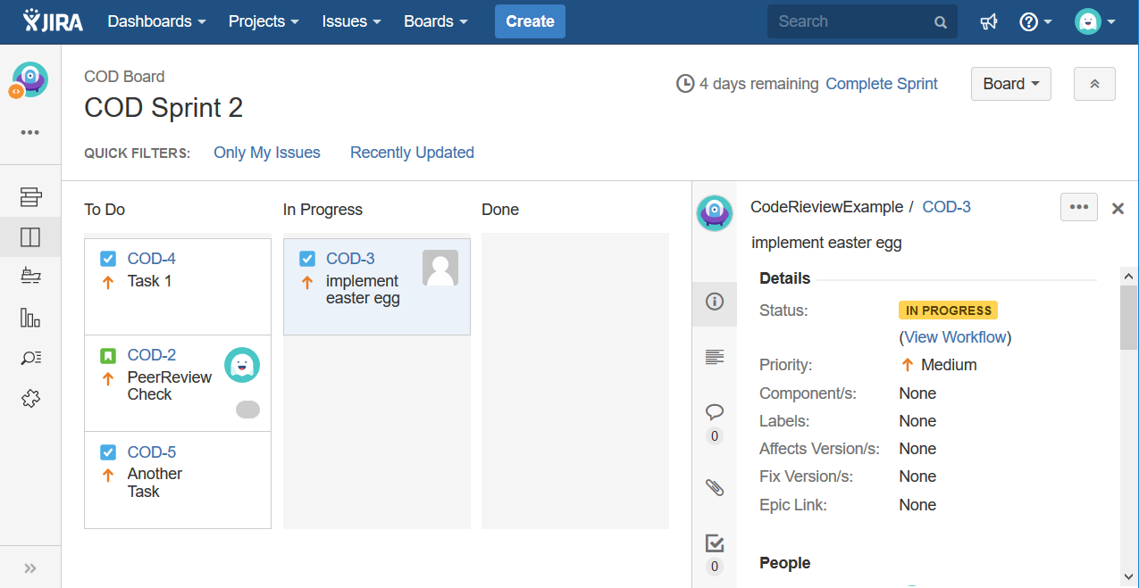

**1) Create the new JIRA Status**

1. Go to the JIRA Administration area.
2. Create a new status called 'Quality Testing'.  
   (Info)See [Defining 'Status' Field Values](https://confluence.atlassian.com/jira/defining-status-field-values-185729494.html) in the *JIRA Administrator's Guide*.

**2) Create a new Step in your JIRA Workflow**

1. Go to the JIRA Administration area.
2. For each JIRA workflow that is associated with issue types that are used by projects on your board,
   1. Edit the JIRA workflow(s).
   2. Add a new step called 'Quality Testing'. In the '**Linked Status**' field, select 'Quality Testing'.  
      (Info)See [Configuring Workflow](https://confluence.atlassian.com/jira/configuring-workflow-185729632.html) in the *JIRA Administrator's Guide*.

**3) Create a new column and map it to the new Status**

1. Go to your JIRA Agile board and click '**Configure**'.

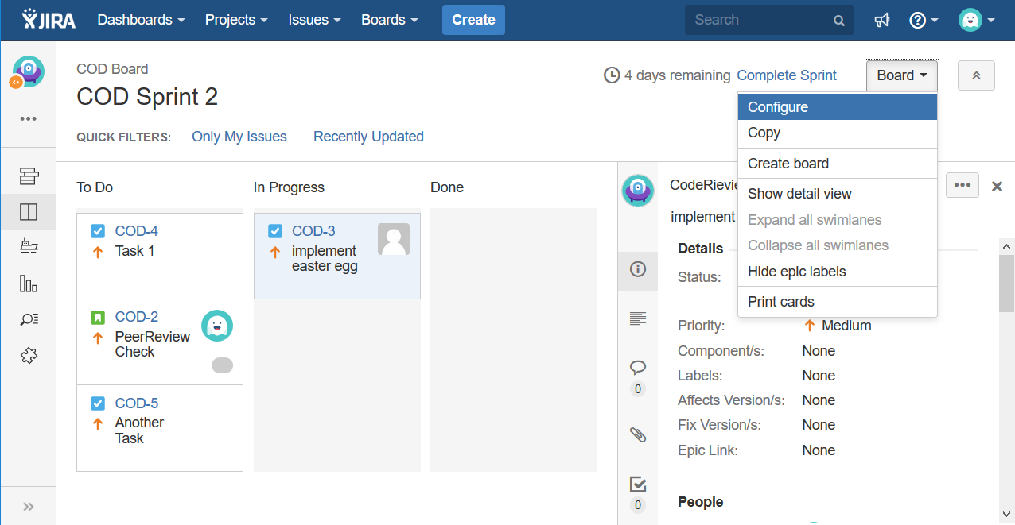

1. Click the '**Columns**' tab, then click '**Add Column**'. A new column named 'New Column' will be added in the 2nd-last column position. (You can drag it into a different position if you wish.)

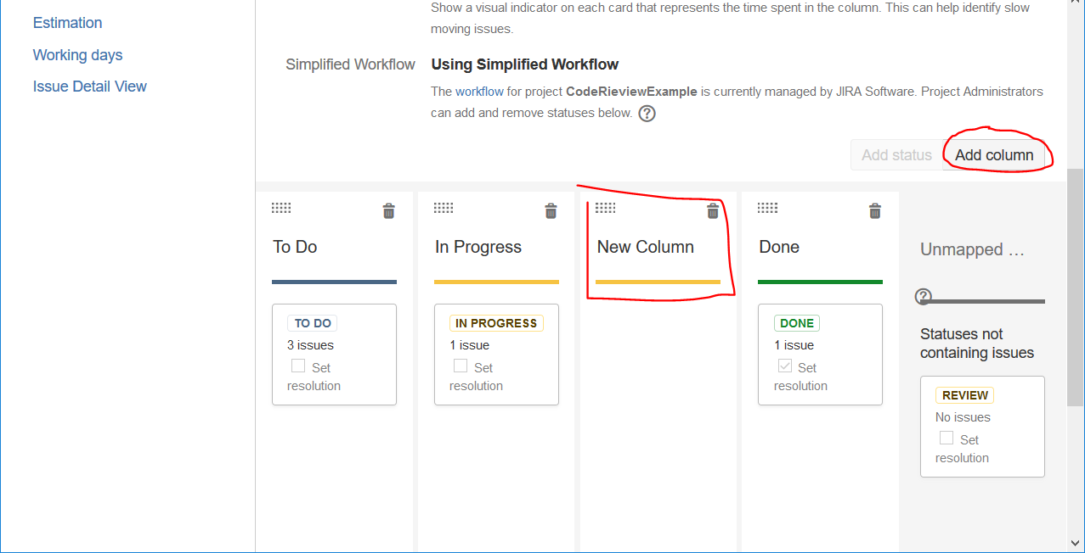

1. Click the name '**New Column**' and rename it to '**Review’**.
2. In the '**Unmapped Statuses**' column at the left of the screen, locate the 'Quality Testing' status and drag it to your new 'Quality Testing' column.  
   (Info)See [Configuring Columns](https://confluence.atlassian.com/agile/jira-agile-user-s-guide/configuring-a-board/configuring-columns).

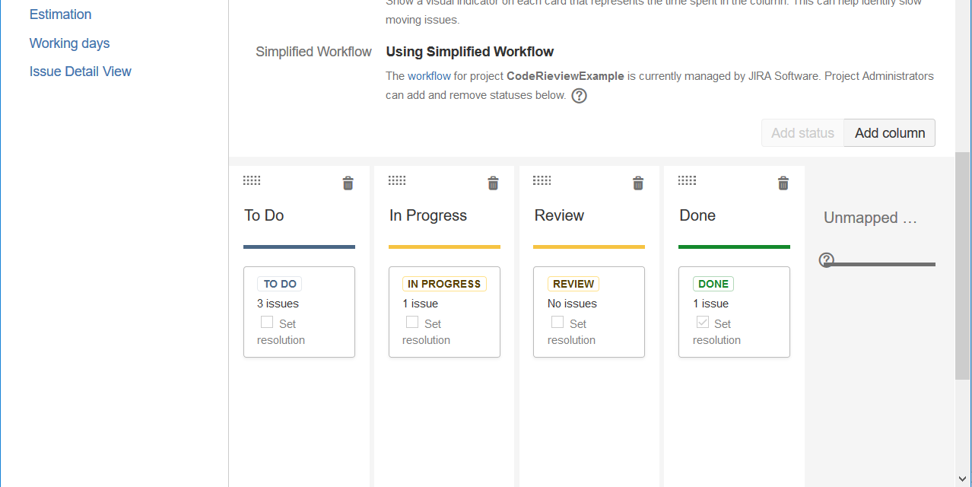

**4) See the result**

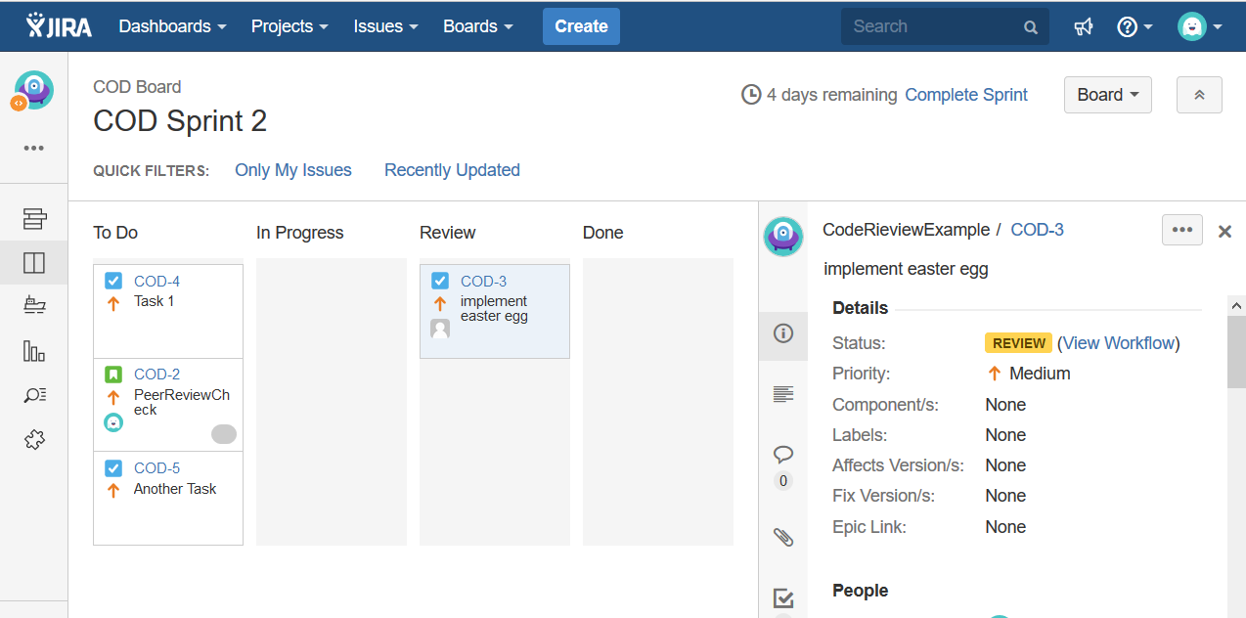

<https://confluence.atlassian.com/agile/jira-agile-user-s-guide/jira-agile-tutorials/tutorial-adding-a-column-to-a-board>